

**Documentation on Programming Mistake Detector (PMD)**

**Created By: Santosh D**

**Reviewed By: Sreenivas P**

**Programming Mistake Detector (PMD):**

* It is an open source static source code analyzer that reports on issues found within application code.
* PMD includes built-in rule sets and supports the ability to write custom rules.
* PMD does not report compilation errors, as it only can process well-formed source files.
* The Issues reported by PMD are rather inefficient code, or bad programming habits, which can reduce the performance and maintainability of the program if they accumulate.
* It can analyze files written in Java, JavaScript, Apex and Visualforce, PLSQL, Apache Velocity, XML, and XSL.

**Feautures:**

PMD can detect flaws or possible flaws in source code, like:

* Possible bugs—Empty try/catch/finally/switch blocks.
* Dead code—Unused local variables, parameters and private methods.
* Empty if/while statements.
* Overcomplicated expressions—Unnecessary if statements, for loops that could be while loops.
* Suboptimal code—Wasteful String/String Buffer usage.
* Classes with high Cyclomatic Complexity measurements.
* Duplicate code—Copied/pasted code can mean copied/pasted bugs and decreases maintainability.

## **Copy/Paste Detector (CPD):**

The **Copy/Paste Detector** (**CPD**) is an add-on to PMD that uses the Rabin–Karp string search algorithm to find duplicated code. Unlike PMD, CPD works with a broader range of languages including Java, Java Server Pages (JSP), C, C++, Fortran, PHP, and C# code.

**Rule set:**

* A ruleset is an XML configuration file, which describes a collection of **rules** to be executed in a **PMD run**.
* **PMD** includes built-in rulesets to **run** quick analyses with a default configuration, but users are encouraged to make their own rulesets from the start, because they allow for so much configurability to create their own custom rules.

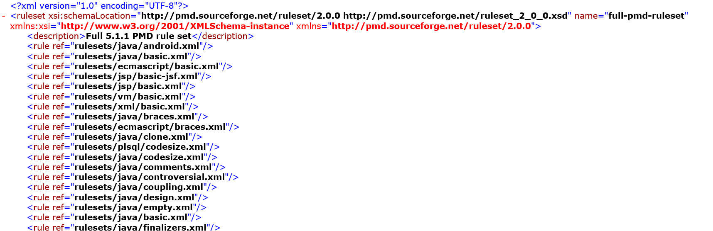

**Pre-requisites:**

1. Install PMD plugin in Eclipse.
2. Create a sample project with sample Program

**How PMD works?**

* **Op**en the project and Right click on Project Select Properties.
* After that Select PMD -> Enable PMD ->Upload the rule set ->Apply and Close.
* Wherever projects enabled with PMD will get the violation and warnings.
* Warnings will give based on the rule set.

When We enable PMD for project it will show the warnings show in below figure

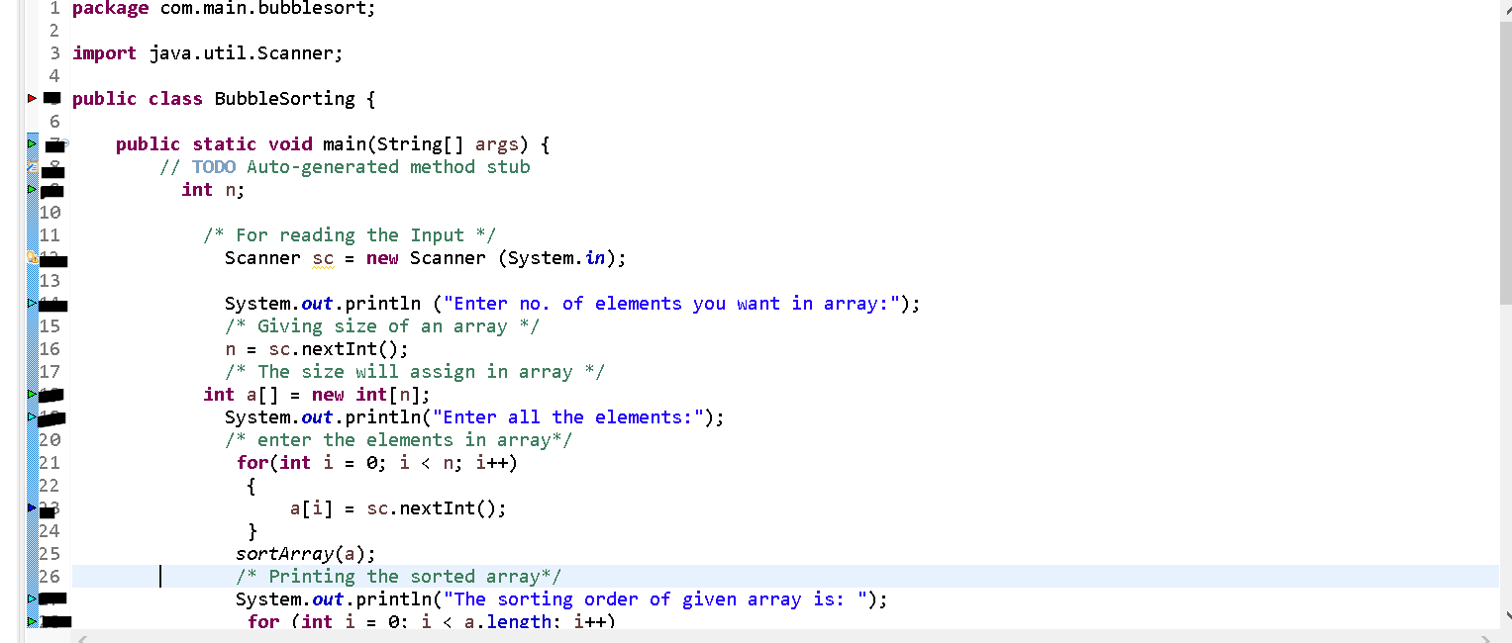

**PMD Rules & flaws:**

* Comment Required: Public method and constructor comments are required
* Method Argument Could Be Final: Parameter 'args' is not assigned and could be declared final
* Short Variable: Avoid variables with short names like n
* ForLoopCanBeForeach: The for loop can be replaced by a foreach loop
* Comment Required: Class comments are required
* AtLeastOneConstructor: Each class should declare at least one